**Title**

**De novo formations of stable cliques in mouse societies requires cortical cognitions enabled by oxytocin**

De novo formations of stable cliques in mouse societies requires oxytocin enabled cortical cognitions

**Authors**

Corentin Nelias1,2,#, Sarah Ghanayem1,2,#, David Wolf1,2, Marcel Moor1, Max F. Scheller1, Carla Filosa1, Valery Grinevich2, Jonathan R. Reinwald1,2,§, Wolfgang Kelsch1,2,§,*

1 Dept. of Psychiatry and Psychotherapy, University Medical Center Mainz, Johannes-Gutenberg University, Untere Zahlbacher Strasse 8, 55131 Mainz, Germany

2 Dept. of Psychiatry and Psychotherapy, Central Institute of Mental Health, Medical Faculty Mannheim, Heidelberg University, Square J5, 68159 Mannheim, Germany

# shared first authors, § shared last authors, * corresponding author: [wokelsch@uni-mainz.de](mailto:wokelsch@uni-mainz.de)

# Abstract

# Stable and reciprocal relationships confer competitive advantages and are essential for higher-level social functioning, yet the neurobiological basis enabling this stability remains incompletely understood. Oxytocin in the anterior olfactory cortex modulates social cognition and recognition memory. Here, we examined how selective reduction of oxytocin receptor activity in this region affects social relationship formation in mice. Mutant mice displayed intact non-social olfactory learning and typical dyadic interaction patterns, suggesting a cognitive-specific deficit. To model sparse genetic variation in naturalistic settings, a small number of mutants were embedded in larger groups of normotypical mice within a semi-naturalistic habitat. Social rank acquisition was largely intact, as was the density of self-initiated social approaches. However, network analysis revealed that while normotypical mice formed “rich clubs”—highly interactive subgroups with stable mutual relationships—mutants failed to integrate into these subgroups. Their outgoing connectivity was less stable, even compared to normotypical mice outside rich clubs. This was accompanied by diminished reciprocation from others and fluctuating social motivation of mutants themselves. The selective inability to form stable relationships parallels impairments observed in higher-functioning autism spectrum disorders, where individuals engage socially but struggle to form deep, reciprocal bonds. These deficits underscore the role of oxytocin in tuning sensory systems into a social cognition state, with profound implications for an individual's ability to establish stable relationships within social networks.

# Introduction 474 words

The ability to form and maintain stable, reciprocal social relationships is central to mental health and adaptive functioning. These relationships are critical for survival, cooperation, and psychological well-being, and are supported by social motivation and cognitive processes, such as sensory processing and recognition [1, 2]. In mammals, structured social networks emerge from repeated interactions, leading to preferential associations that may stabilize into enduring dyads or complex affiliative subgroups [3].

Importantly, impairments in higher-order social behavior may not manifest as reduced social interest or interaction frequency, but rather as a diminished ability to occupy and maintain functional roles within dynamic social networks [4, 5]. This distinction is   
particularly relevant in neurodevelopmental and psychiatric conditions such as high-functioning autism spectrum disorder (ASD), where social motivation is often preserved, yet the capacity to establish and maintain stable, reciprocal social bonds is impaired [6, 7]. These challenges become especially pronounced in adulthood as social environments increase in complexity and require flexible integration into new social networks. Difficulties in meeting these demands are associated with long-term psychosocial and economic outcomes [8].

Network theory has highlighted the role of tightly connected social subgroups in maintaining network cohesion and resilience [9]. While such structures are well-documented in human and digital social systems [10], their spontaneous formation   
in animal models, and the neurobiological mechanisms that support them, remain poorly understood. Identifying how individuals gain stable access to these high-value social structures may offer new insight into the subtle cognitive and neural underpinnings of social integration deficits in psychiatric disorders.

Oxytocin is a well-established neuromodulator of social cognition across species, influencing social recognition, affiliative behavior, and bonding [11–15]. Its central role in modulating group cohesion and social salience has led to therapeutic interest in ASD and related conditions [16, 17]. However, despite promising preclinical data, clinical trials of intranasal oxytocin have yielded inconsistent outcomes, underscoring the importance of context, circuit specificity, and individual variability in determining efficacy [18, 19].   
Clarifying oxytocin’s role in naturalistic, socially complex settings is therefore critical for understanding its function and for refining therapeutic strategies.

Brain genotypes: mimicking regional expression heterogeneity

We hypothesized that oxytocin receptor (OXTR) signaling in the anterior olfactory nucleus (AON)—a key region involved in modulating olfactory inputs relevant for social recognition [13, 15]—contributes to the formation and stabilization of affiliative bonds in group-living animals.

Add here Kendrick, Oettl Wolf and others

Add human olfactory,

Using adult mice with selective OXTR deletion in the AON (OXTR∆AON), we preserve normal neurodevelopment and prior social experience, allowing us to isolate the contribution of ~~this circuit to network-level behavior~~.

Elaborate here on increasing complexity approach along with Cisek and others: without losing precision! (add scheme)

Requirements for complexity:

* Track individuals
  + Longitudinal
  + In sufficient group sizes for social networks:
    - Also: groups of four despotic hierarchies
* Group dynamics: novel versus family bonds
  + Need for massive data (time x sample size) to … (Cisek)
* And interventional population genetics to identify causal mechanisms enabling stable relationships
* And multiple social domains captured to put social relations into perspective with social rank and agonistic behavior
* The NoSeMaze consists of an open-field arena equipped with 24/7 video monitoring and a housing arena with nesting material and free access to food (Fig. 2A, Suppl. Fig. S2). These arenas are connected via two tubes equipped with multiple RFID readers, which allow for continuous, automated tracking of individual mice. Mice can perform ad libitum trials in an olfactory stimulus-outcome learning module to earn their daily water needs. The module is connected to the open-field arena, ensuring that animals traverse the tubes between arenas to obtain both food and water, thereby integrating movement, reinforcement learning, and social events.

Social interactions allow individuals to gather information and recognize conspecifics, with interaction patterns potentially differing between neurotypical individuals and those with oxytocin signaling deficits. To investigate whether altered OXT function in the AON impacts dyadic interaction patterns, we examined the microstructure of self-paced social encounters in a controlled setting.

Rich club

borrowed from …

advantage of this concept

We first demonstrate that OXTR∆AON mice exhibit intact non-social olfactory learning and dyadic interaction patterns, consistent with a selective cognitive phenotype. We then assess their ability to integrate into complex social networks, focusing on social hierarchy, agonistic interactions, and the formation of stable affiliative substructures. These findings illuminate how circuit-specific oxytocin signaling facilitates the emergence of durable social relationships, and how its disruption may model features of social dysfunction seen in ASD and related disorders.

# Results

**OXTR deletion in the AON does not alter brief dyadic social interaction patterns**

It is not known if loss of OXT signaling in the AON affects the microstructure of self-paced dyadic same-sex interactions. We therefore probed their interaction states and transitions between them in controlled conditions that allow for high resolution mapping of these behaviors (Fig. 1a,b). We benchmarked a cohort with selective adult deletion of OXTR in the AON (OXTRΔAON with bilateral injection of AAV1/2-CBA-Cre in adult male OXTRfl/fl mice) and its matched controls (Fig. 1c) against a cohort of mice with optogenetics-boosted global OXT release throughout the forebrain (AAV-mediated conditional ChR2 expression in the paraventricular nucleus of male OXT-Cre mice) and its matched controls (Fig.1d). As hypothesized, boosted OXT release led to a tendency toward more sampling events, with significantly shorter durations (Fig. 1e), suggesting subtle facilitation of interactions. In contrast, OXTRΔAON mice did not differ from controls in the number or duration of interaction states (Fig. 1f). Boosted OXT release led to more frequent transitions from approach into sampling behaviors and a decrease of aborted interactions after approaches were initiated (Fig. 1h), consistent with enhanced social engagement. By contrast, OXTRΔAON mice showed no significant differences from matched controls in transition probabilities (Fig. 1i). Partner behavior remained unchanged across all groups (Supplementary Fig. 2), indicating no reactive effects during brief interactions.

In summary, selective deletion of OXTR in the AON did not alter dyadic social interaction behavior during brief interactions, consistent with OXT acting mainly on social cognition in this cortex. We therefore wondered what consequences the selective impairment in social cognition may have in complex and dynamic social networks.

# 

Fig. 1

**OXTRΔAON mice display quantitatively normal social activity in naturalistic group settings**

To assess the social interaction dynamics in a complex naturalistic retaining control of complete tracking of individual behavior, we employed the NoSeMaze system (Reinwald et al., 2025). The NoSeMaze provides a semi-naturalistic sensor-rich environment enabling long-term, automated tracking of cognitive and social behaviors in group-housed mice without human interference (Fig. 2a). Groups of 9-10 RFID-chipped mice – each including two to four OXTRΔAON individuals interspersed among controls to mimic naturalistic sparse genetic (total of 79 male mice (XX OXTRΔAON and XX control mice) – were monitored over continuous three week-rounds without experimenter intervention across. We tested separate subgroups of younger adults (16–30 weeks) and older adults (55–97 weeks) to assure that phenotypes were stable across the adult lifespan (Fig. 2b). To assess which social behaviors depend on specific group configurations, mice lived in each round with different peers in the NoSeMaze (‘reshuffling’, Fig. 2b).

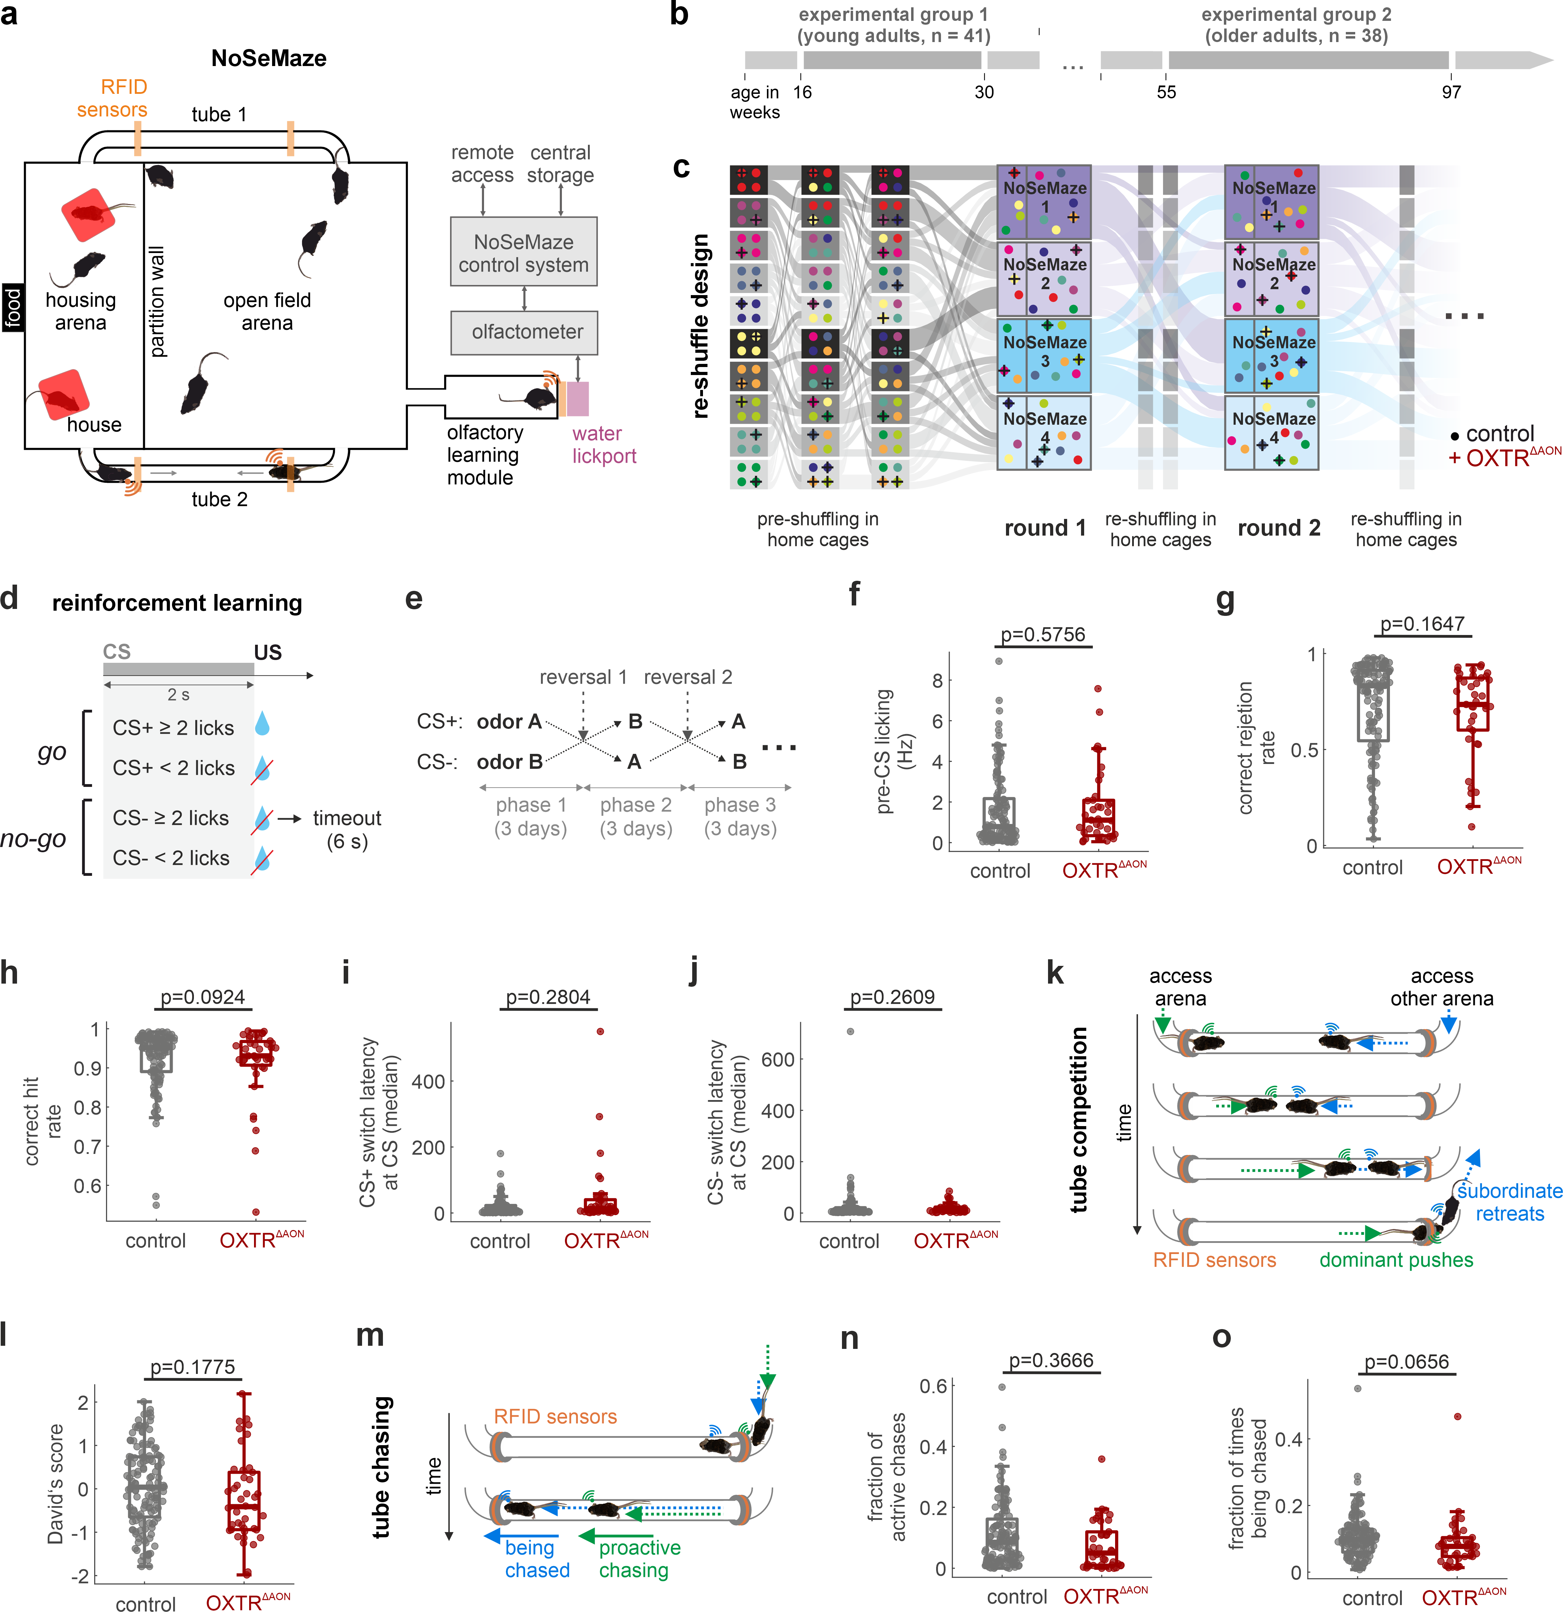

Fig. 2

We then established a pipeline to extract the social interaction networks of the groups of individually identified mice including interspersed OXTRΔAON mutants from the continuous video data in the open field arena in 17 rounds total Fig. 3a-b). To identify each mouse, distinct patterns had been bleached in the fur on the back before the round (Fig. 3c). We analyzed the first 15 days of each round as fur regrew and pattern identification by the trained RNN became less reliably. Before the start of the next round the fur pattern was refreshed. Approximately 6.100 hours of continuous video data entered into the social networks (Fig. 3d).

The RNN-based pipeline outputted the spatial coordinates associated to the position of each animal as a function of time. From the tracked positions, we defined and extracted two different types of social events of interest: interactions and approaches. This allowed us to represent the data as a social network. Interactions, which yielded undirected networks, were counted whenever the distance between two animals was less than 10 cm for at least 1.0 second (Fig 3e). We defined approaches by calculating the distances travelled in the 4 seconds before the interaction for both interaction partners (Fig. 3f). If the ratio of travelled distances of mouse A to mouse B exceeded 1.5, mouse A was considered the approaching one. Otherwise, no approach was counted, for example in cases where they equally approached each other. Approaches performed between each mice yielded a directed network. We obtained time series of undirected and directed networks (Fig. 3g-h, see Methods). Spatially, interactions preferentially occurred closer to the walls of the open arena (Fig. 3i-j) and during the active dark cycle (Fig. 3k). Notably, OXTRΔAON and control mice displayed quantitatively similar number of interactions and event durations (Fig. 3l-m) as well as number of both ingoing and outgoing approaches (Fig. 3n-o), suggesting preserved approach behavior in mice carrying OXTRΔAON. We therefore tested the hypothesis that social cognition deficits affect the building of targeted and thus consistent social relationships.

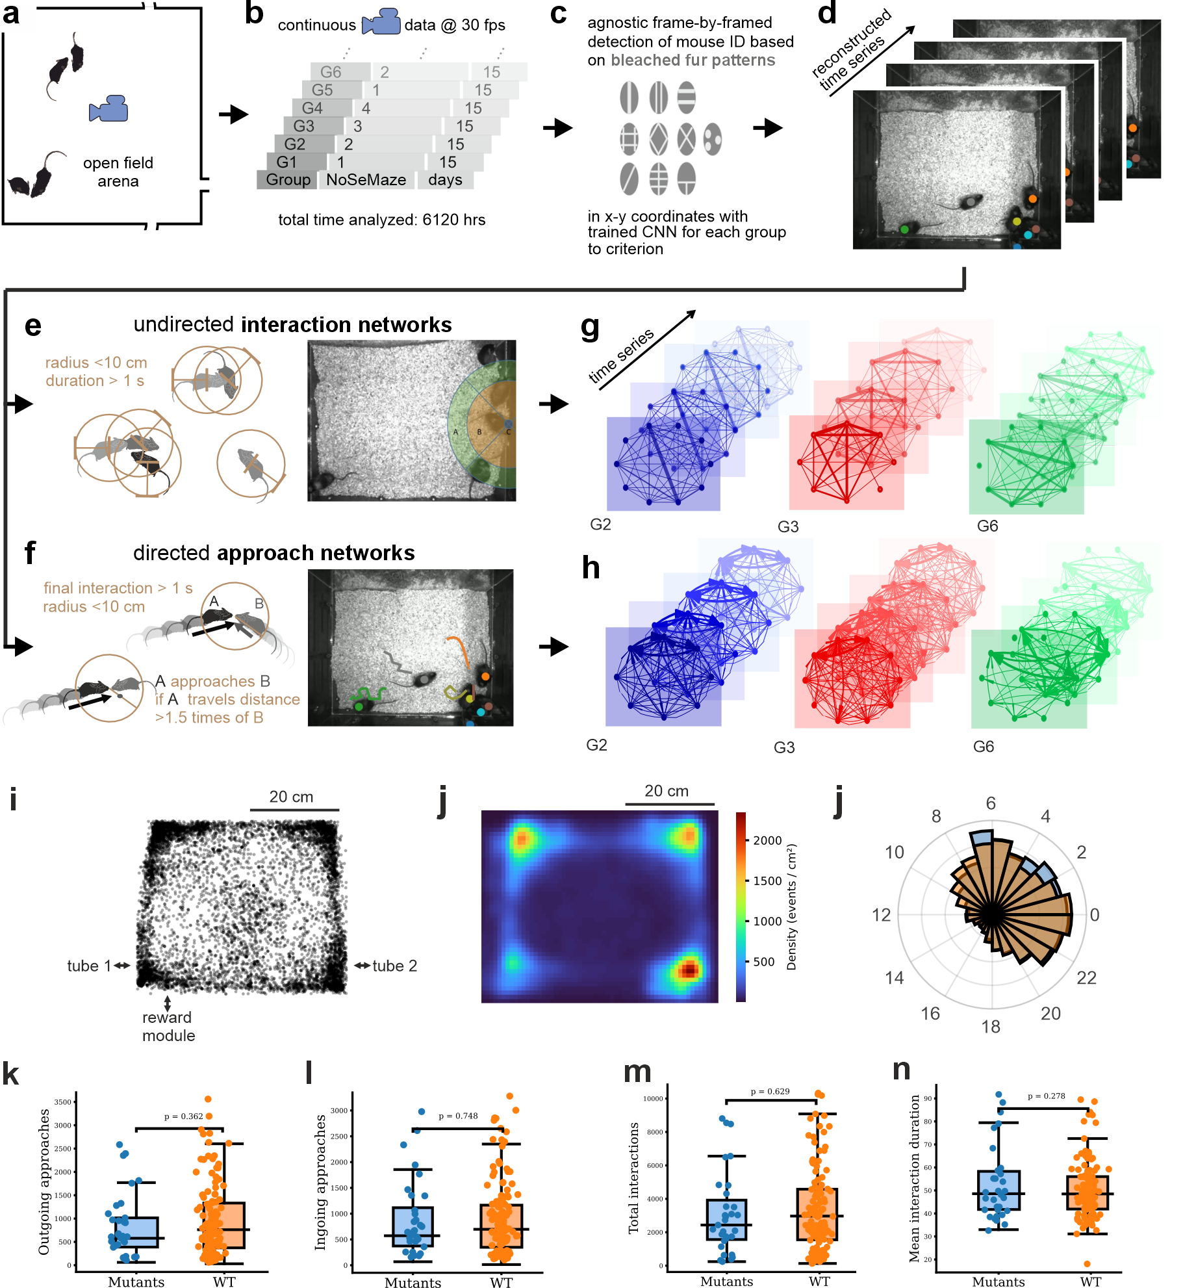

Fig. 3

**Stable rich clubs emerge in social networks of group-housed mice**

While some social relationships may be instable dynamic and occur by chance or are not stabilized by reciprocal behaviors, others gain stability and persist for the time a group of animals live in the same habitat. We were particularly interested here in identifying the key factors that enable the formation of such stable reciprocal cliques within larger groups.

Interaction data were analyzed across five consecutive 3-day windows per round. Given the high baseline connectivity in the networks, graphs were pruned using a mutual nearest-neighbor algorithm to isolate stable and behaviorally relevant substructures (Fig. 4a; Supplementary Fig. X). In most cohorts (81%), we observed the emergence of stable, densely interconnected subnetworks composed of high-degree nodes. These structures represent rich clubs (RC; CITE, Fig. 4b–c). RCs that persisted across at least 4 out of 5 3-day-graphs were considered stable rich clubs (sRC). Notably, sRC were robustly identifiable in both undirected interaction and directed approach networks. Statistical modeling confirmed that such persistence was highly unlikely to occur by chance (p < 10⁻⁷ for pairs; p < 10⁻⁹ for triads), indicating genuine social structure.

sRC members displayed distinct interaction behaviors. Compared to non-members, they engaged in more interactions and approaches (Fig. 4d–f), although approach duration did not differ (Fig. 4g). Notably, OXTRΔAON mice behaved quantitatively similarly as non-members in these measures (Fig. 4d–g). sRC members also exhibited greater reciprocity: 96.0% of their approaches were reciprocal, compared to 67.7% in the general population (Fig. 4h). Thus, stable rich clubs form in most of the groups in the NoSeMaze and can be identified both from undirected interaction graphs and directional approach networks.

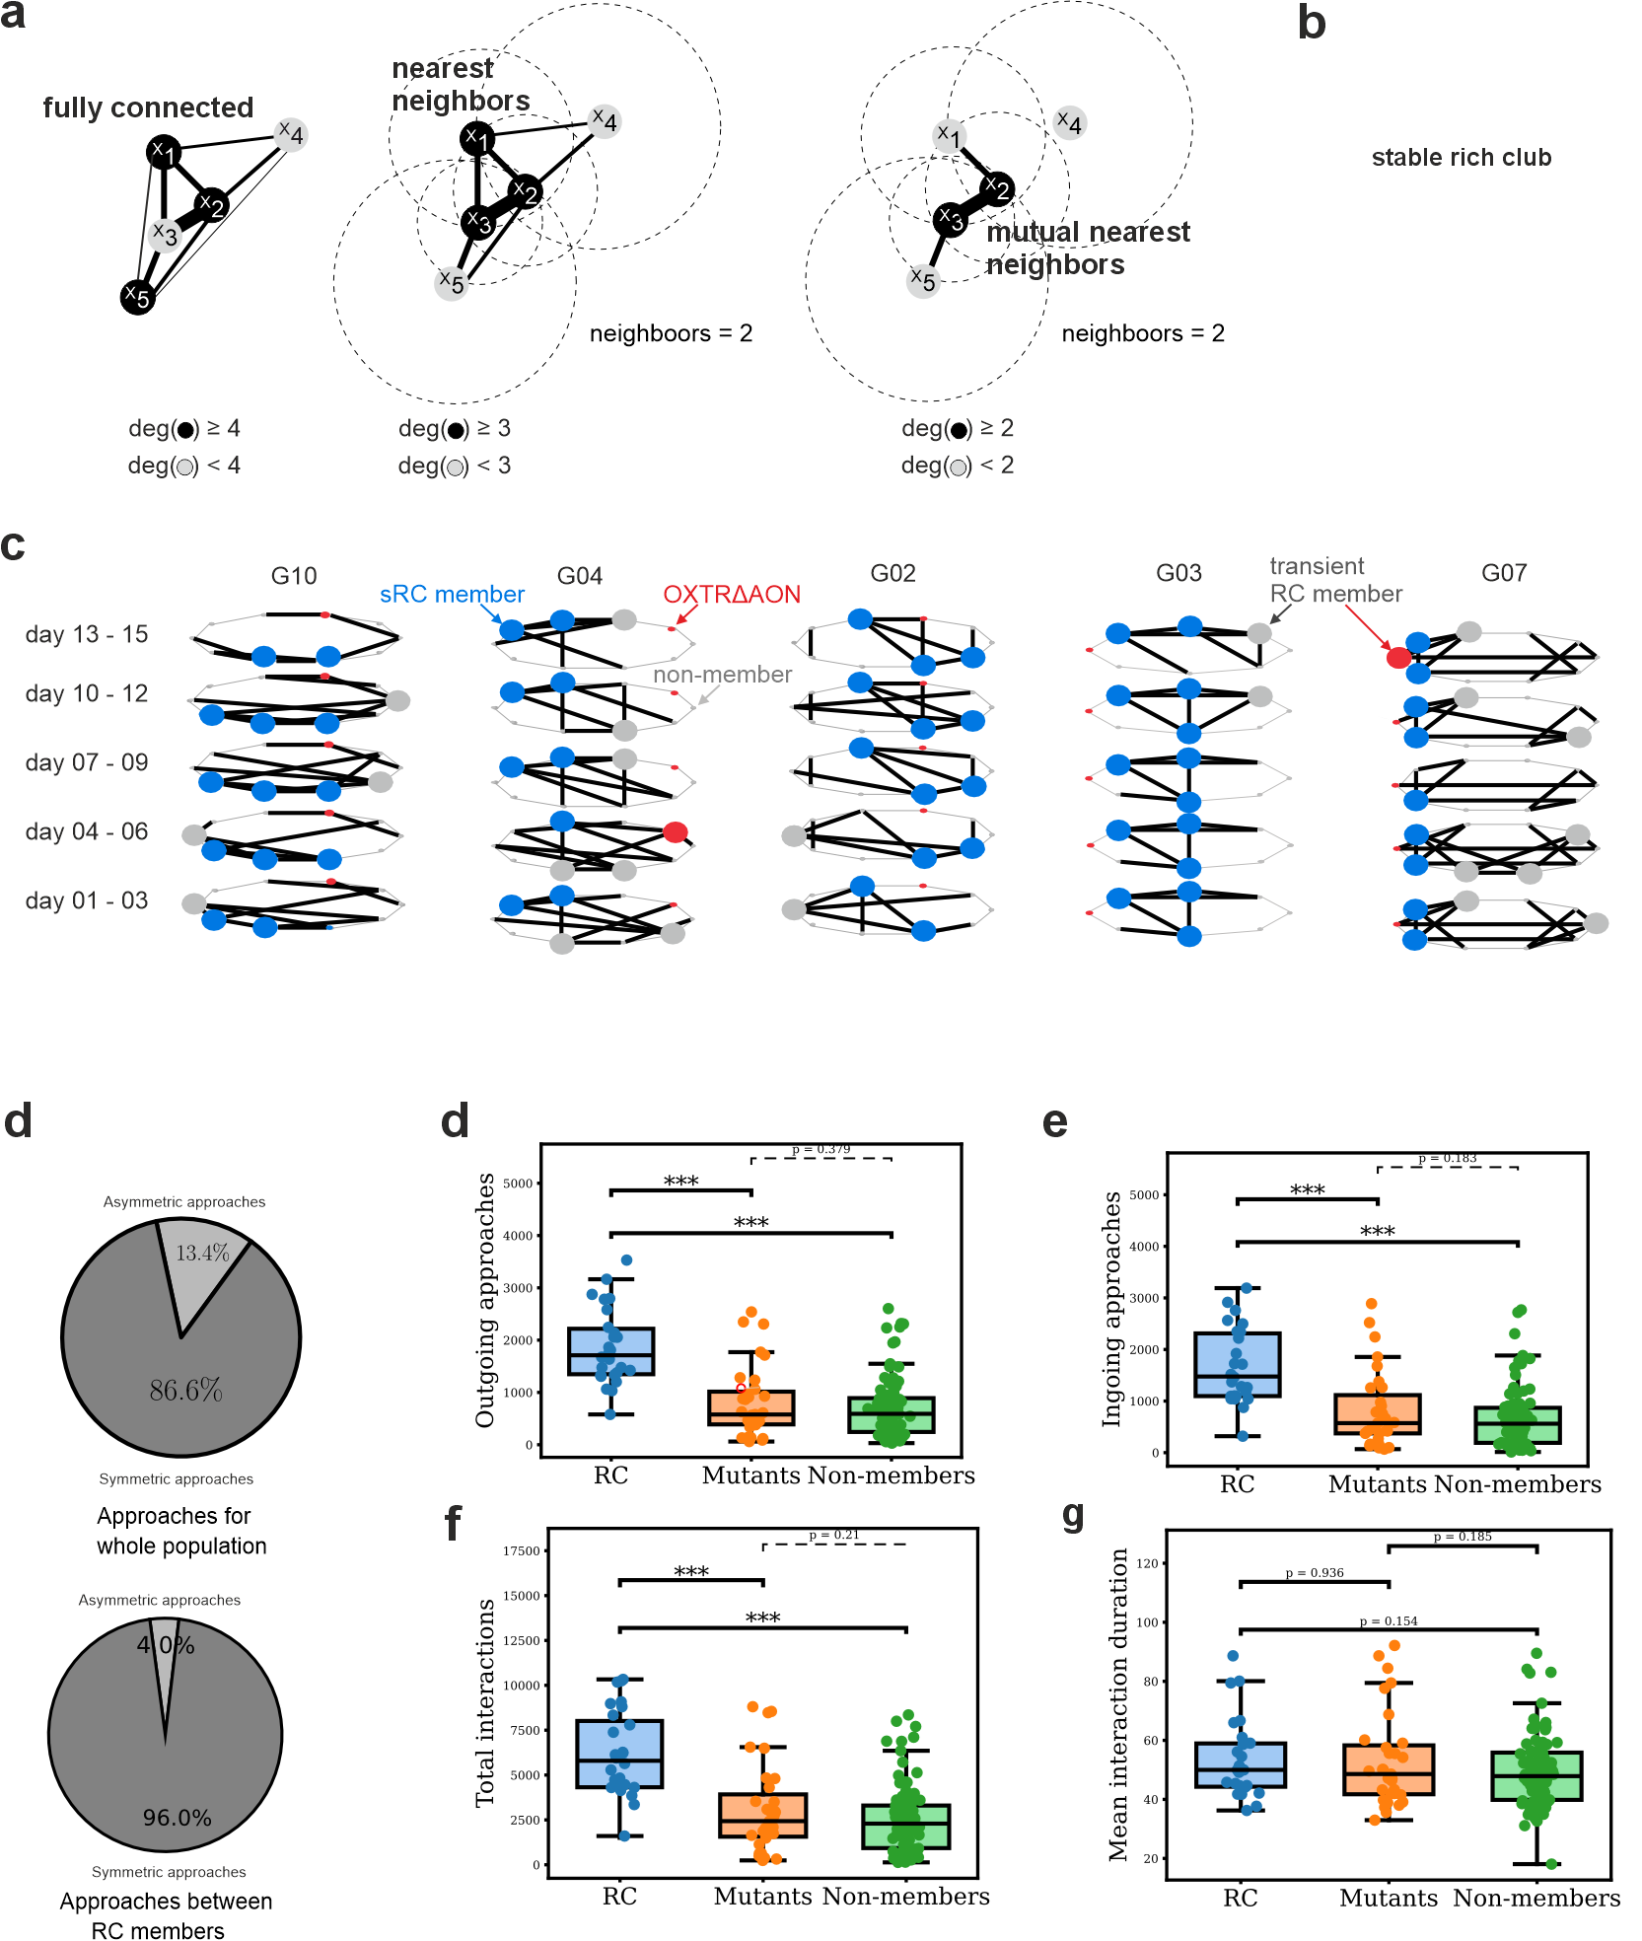

Fig. 4

**Rich club membership emerges from group-specific dynamics** Stable RC membership came with differences in other social behaviors. In social rank networks derived from dyadic competitions in the tubes of the NoSeMaze (Fig. 5a, c.f. Reinwald et al., 2025), sRC members tended to occupy higher positions in the social hierarchy (Fig. 5b). The distribution of social ranks however had a large variance among sRC members, suggesting that high social rank might promote, but does not guarantee sRC membership. We also testes for proactive chasing of others through the tubes (Fig. 5c). sRC members initiated more chases than non-members (Fig. 5d). [[[TBD: Fig. 5e-f: how do we summarize the normalized and not inside and outside chasing? And, we have to say something about being chased.]]]

We next tested predictions on the nature of sRC. Firstly, sRC may emerge from the interplay among specific individuals. Thus, shared upbringing may be a factor promoting shared sRC membership in the adult also in larger groups. We took advantage that we had multiple siblings per group. However, kinship (Fig. 2g) did not increase the likelihood to become a member in a sRC above random chance (Fig. 2h). Secondly, prior membership experience might promote sRC membership in the next round. Alternatively, this might depend more on the specific group dynamics. To test this, we took advantage of the reshuffling of the mice that configured different group compositions in consecutive rounds (Fig. 5i, cf. Fig. 2b). Among mice participating in multiple NoSeMaze rounds, the probability of re-entering a sRC did not exceed chance (Fig. 5j), suggesting that sRC membership is not an intrinsic individual attribute, but instead emerges de novo from the specific social dynamics within each group. This contrasts with the two other social behaviors, social rank and proactive chasing, that become internalized in individuals and are largely maintained across different group configurations (Reinwald et al, 2025). Notably, OXTRΔAON and normotypical mice differed neither in their mean hierarchy (Fig. 5k) nor in their expression of chasing behavior (Fig. 5l-m).

In summary, most groups in the NoSeMaze form stable interconnected social structures that can be described as RCs. We found that mice in the RCs were significantly more active, engaged in more reciprocal interactions, and initiated more chasings than non-members. Owing to the fact that family relationships did not significantly influence rich club formation, and that most mice that entered the club did not integrate it again with new peers, we conclude that sRC formation is an emergent property reflecting the dynamic nature of the social interaction within each group.

**OXTRΔAON mice fail to integrate into stable rich clubs**

Since the formation of rich clubs in colonies appears to be a consequence of higher-order social interactions, a crucial question is whether OXTRΔAON mice enter them or not. OXTRΔAON mice have been shown to suffer from social cognition deficits (CITE).While these deficiencies did not lead to significant differences in the way mice partake in dyadic interactions (cf. Fig. 1 and 5h-i), it is very well possible that OXTRΔAON mice lack the capacity to engage in complex stable social relationships. To answer this question, we compared the number of OXTRΔAON mice that were able to enter the rich club to the one that would be expected by random chance using a bootstrap approach. The results (Fig. 5n) show that OXTRΔAON mice are significantly less likely to enter the sRC than control mice. In summary, OXT signaling in the AON plays a crucial role in the formation of social cliques that form de novo among mice in larger groups (cf. Fgi. 5i).

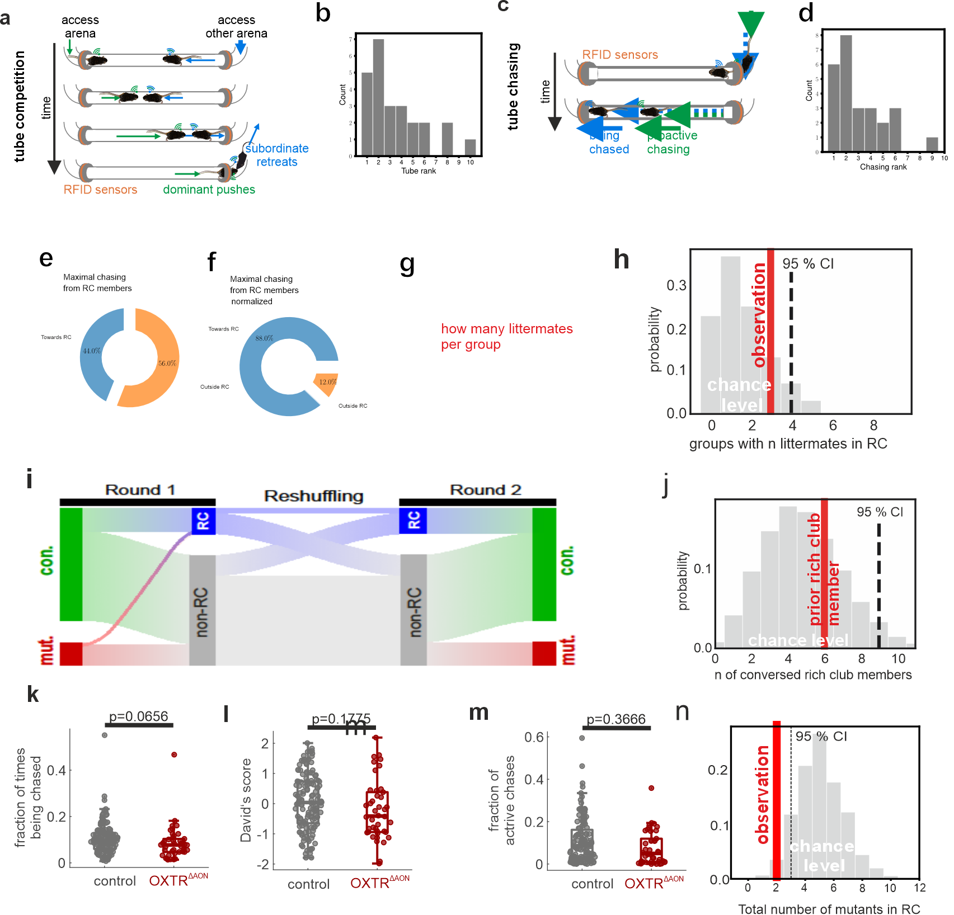

Fig. 5

**Unstable network dynamics in OXTRΔAON mice hinder social integration**

Although OXTRΔAON and control mice showed no differences in average measures of interaction time, approach frequency or social rank, OXTRΔAON mice failed to enter sRCs. To better understand the deficits emerging from this brain genotype, we analyzed how their social network connections behave as a function of time. Stronger fluctuation levels may explain the mutants’ inability to engage in stable relationships with others. Specifically, we examined fluctuations in directional approach networks, using the time derivatives of key graph metrics to assess instability. To avoid confounds from current RC membership, comparisons were made between OXTRΔAON mice and normotypic non-members, the latter of whom could nonetheless be sRC members in other rounds. We thereby isolated latent deficits specific to the OXTRΔAON phenotype.

We first focused on the stability of outgoing connections of mice carrying OXTRΔAON. Indeed, the outgoing strength (Fig. 7a–b) fluctuated significantly more in OXTRΔAON mice (Fig. 7c–d). Outgoing strength measures the total number of approaches performed by a mouse on the day independent of how many different mice were approached, thus reflecting also general social motivation (cf. Fig. 7a). In contrast, the out-degree measures the normalized intensity of approaches to other mice and thus is largely independent of the total number of approaches performed that day (Fig. 7e). Instability was also observed in out-degree, (Fig. 7f–h), supporting that while OXTRΔAON mice are socially active, their partner selection is more erratic.

To assess fluctuation levels in specific connections, we drew inspiration from the field of temporal graphs and propose a measurement that we call ‘persistence’ to study how connections between two partners are preserved in time. We define persistence as the number of preserved edges over time (see Fig 7i). Indeed, OXTRΔAON mice form less persistent edges than normotypical non-sRC-members (Fig 7j).

We next asked whether this instability also affects the way OXTRΔAON mice were perceived within the group. Fluctuations in ingoing strength were moderately higher in OXTRΔAON mice (Fig. 7k). A similar trend was observed for in-degree (Supplementary Fig. X). We therefore assessed how OXTRΔAON mice were socially embedded in the group by analyzing the time derivative of the in-Jaccard index, a network measure quantifying graph similarity that is the overlap in social partners over time (Fig. 7l). Indeed, this index fluctuated more strongly for OXTRΔAON mice (Fig. 7m), suggesting that their role within the group structure was less stable than that of controls. Together, these findings reveal that mice carrying OXTRΔAON not only initiate relationships less consistently, but also evoke more variable responses from peers (Fig. 7n).

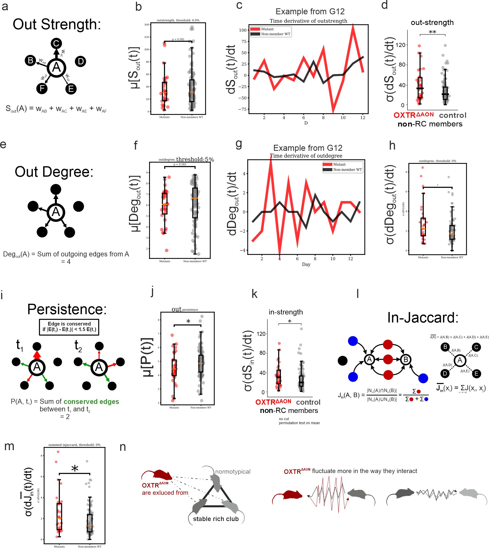

Notes: add blinding in the methods (for the OXTR-KO)

# Discussion 949 words

Our findings provide compelling evidence that oxytocin signaling in the anterior olfactory cortex modulates social cognitions that are crucial for the formation of stable social relationships in mice. Specifically, while OXTRΔAON mutants displayed intact social motivation and dyadic interactions, they failed to integrate into stable, highly interconnected social subgroups, or "rich clubs".

Deciphering the multiple roles of neuromodulators on social behavior requires investigating interactions at multiple levels of complexity [5]. Reductionist behavioral assays may not capture emergent social structures, as genotypic variations may only manifest in ecologically relevant conditions [19]. The NoSeMaze system allowed us to study self-paced interactions in freely moving mouse colonies, providing an opportunity to assess the supra-organismal effects of OXTR dysfunction at the network level. By interspersing a minority of mutants within a wild-type population, we mimicked sparse genetic variations found in natural societies while avoiding artificial shifts in collective behavior. This approach revealed that, despite displaying normal social approach behavior and intact dyadic interaction sequences, OXTRΔAON mutants exhibited profound impairments in forming structured social relationships.

This dissociation between simple social behaviors and higher-order social integration aligns with observations in high-functioning autism spectrum disorder (ASD) [6, 7], where individuals may engage in social interactions yet struggle to form deep, reciprocal bonds. Our results highlight the importance of studying complex behaviors beyond isolated social motifs, as deficits in structured social cognition may not be evident when considering only basic interaction frequencies [2].

Rich clubs represent a fundamental aspect of social network organization in both humans and animals [9, 17, 20], forming stable hubs within social systems. Our findings demonstrate that normotypic mice generally establish rich clubs shortly after being introduced into a social environment and maintain membership over time. However, these structures are not intrinsic to individuals but may emerge from group-specific dynamics [10], as evidenced here by the fact that previous rich club members were not more likely to re-enter a rich club when introduced to a new social group. This suggests that structured social bonding is an adaptive and situationally learned process rather than a fixed individual trait.

Notably, OXTRΔAON mutants failed to enter rich clubs despite exhibiting typical social hierarchy positioning. This suggests that rich club formation relies on oxytocin-dependent social learning [13, 15], reinforcing the notion that stable, reciprocal social bonds require cognitive processes beyond mere social engagement. This distinction between social rank and structured social relations parallels human social hierarchies [21], where status may facilitate but does not determine the ability to form close, reciprocal relationships.  
The differential effects of OXTRΔAON deletion on social rank and rich club membership indicate that these two aspects of social behavior are governed by distinct mechanisms. Social rank, which remained intact in mutants, appears to be an internalized trait, learned through past experiences and maintained across different social groups. In contrast, rich club membership requires continuous social learning and the ability to form and retain structured relationships in novel environments. The observed preservation of social rank despite deficits in structured social bonding highlights a role of oxytocin in enabling dynamic, reciprocal social learning rather than establishing fixed social traits. Given that OXTR was deleted in adulthood, all mice had the opportunity to acquire social rank during development.

The inability to form new, stable social relationships in novel environments is a key feature of ASD and other social disorders [7, 8]. Many individuals with ASD function well in rigid, structured environments but struggle with flexible, self-directed social interactions [22], particularly in forming friendships. This deficit often only becomes apparent in adolescence or adulthood when individuals face increased social complexity [23]. Our findings suggest that selectively impairing oxytocin signaling in a cortex that contributes to social cognition, exhibits a comparable phenotype. The oxytocin signaling in this sensory cortical region is critical for the cognitive processes that underpin de novo social bonding rather than simply facilitating social approach behavior. Mice with OXTRΔAON engage in social interactions but fail to build structured relationships in novel group settings.

Notably, OXTRΔAON mice maintained a normal intensity of approaches to others in the maze; however, their approaches fluctuated substantially more, even compared to normotypic mice not in a rich club. Importantly, social networks are dynamic systems, where altered behavior in one individual can affect others' behavior [10, 24]. Indeed, we observed that others connected to the mutants interacted with them in a less stable fashion. Such social impairments exist along a continuum in the general population [25], influencing personal and professional outcomes [26]. By identifying a neural mechanism underlying these deficits, our study provides a framework for investigating interventions that enhance social network integration.

By integrating molecular, network, and behavioral analyses, our study advances understanding of complex social behaviors in genetically tractable mammalian models. The NoSeMaze system offers a novel method for studying social cognition under ecologically relevant conditions. Our findings underscore the need for therapeutic strategies that target social processing deficits. These results pave the way for future research into oxytocin’s role in structured social integration, particularly in the context of neurodevelopmental disorders. The platform may help to disentangle oxytocin’s multifaceted functions in different modulated brain regions on social cognition, but also on social motivation and other aspects [16, 17]. It will also allow investigate how direct and compensatory effects of early-life oxytocin disruptions influence social rank acquisition and whether targeted interventions can restore structured social bonding in affected individuals [12, 27].

In conclusion, our study demonstrates that oxytocin is essential for the formation of structured, reciprocal social relationships, rather than simply enabling social interactions. While OXTRΔAON mutants exhibited intact social motivation and dyadic interactions, they were unable to integrate into stable social subgroups, highlighting oxytocin’s role in supporting higher-order social cognition. These findings provide critical insight into the neurobiology of social network formation and may inform the development of targeted interventions for individuals with social impairments, such as those observed in ASD and other psychiatric conditions.

OR

Difficulties in forming and sustaining stable, reciprocal social relationships are a hallmark of several neurodevelopmental and psychiatric disorders, including high-functioning autism spectrum disorder. These deficits often emerge not as a lack of social interest, but as an impaired ability to integrate into complex social networks over time. Our findings demonstrate that selective disruption of oxytocin signaling in the anterior olfactory nucleus impairs the formation of stable affiliative bonds in socially rich environments, despite preserved basic social motivation and dyadic interaction patterns. This dissociation between social engagement and network integration mirrors clinical observations and underscores the need to assess social cognition within ecologically valid, group-level contexts. By linking specific circuit-level disruptions to higher-order social outcomes, this work advances our understanding of how subtle cognitive impairments translate into real-world social dysfunction, and may inform more targeted interventions for individuals with context-dependent social deficits.

Where do we add increasing complexity [28]

# References

1. Adolphs R. The social brain: neural basis of social knowledge. Annu Rev Psychol. 2009;60:693–716.

2. Frith CD, Frith U. The neural basis of mentalizing. Neuron. 2006;50:531–534.

3. Kappeler PM, Clutton-Brock T, Shultz S, Lukas D. Social complexity: patterns, processes, and evolution. Behav Ecol Sociobiol. 2019;73:5.

4. Bicks LK, Yamamuro K, Flanigan ME, Kim JM, Kato D, Lucas EK, et al. Prefrontal parvalbumin interneurons require juvenile social experience to establish adult social behavior. Nat Commun. 2020;11:1003.

5. Insel TR. The challenge of translation in social neuroscience: a review of oxytocin, vasopressin, and affiliative behavior. Neuron. 2010;65:768–779.

6. Chevallier C, Kohls G, Troiani V, Brodkin ES, Schultz RT. The social motivation theory of autism. Trends Cogn Sci. 2012;16:231–239.

7. Pelphrey KA, Carter EJ. Brain mechanisms for social perception: lessons from autism and typical development. Ann N Y Acad Sci. 2008;1145:283–299.

8. Howlin P, Goode S, Hutton J, Rutter M. Adult outcome for children with autism. J Child Psychol Psychiatry. 2004;45:212–229.

9. van den Heuvel MP, Sporns O. Rich-club organization of the human connectome. J Neurosci Off J Soc Neurosci. 2011;31:15775–15786.

10. Centola D. The spread of behavior in an online social network experiment. Science. 2010;329:1194–1197.

11. Donaldson ZR, Young LJ. Oxytocin, vasopressin, and the neurogenetics of sociality. Science. 2008;322:900–904.

12. Marlin BJ, Mitre M, D’amour JA, Chao MV, Froemke RC. Oxytocin enables maternal behaviour by balancing cortical inhibition. Nature. 2015;520:499–504.

13. Oettl L-L, Ravi N, Schneider M, Scheller MF, Schneider P, Mitre M, et al. Oxytocin Enhances Social Recognition by Modulating Cortical Control of Early Olfactory Processing. Neuron. 2016;90:609–621.

14. Ferguson JN, Young LJ, Hearn EF, Matzuk MM, Insel TR, Winslow JT. Social amnesia in mice lacking the oxytocin gene. Nat Genet. 2000;25:284–288.

15. Wolf D, Hartig R, Zhuo Y, Scheller MF, Articus M, Moor M, et al. Oxytocin induces the formation of distinctive cortical representations and cognitions biased toward familiar mice. Nat Commun. 2024;15:6274.

16. Guastella AJ, MacLeod C. A critical review of the influence of oxytocin nasal spray on social cognition in humans: evidence and future directions. Horm Behav. 2012;61:410–418.

17. Yamasue H, Okada T, Munesue T, Kuroda M, Fujioka T, Uno Y, et al. Effect of intranasal oxytocin on the core social symptoms of autism spectrum disorder: a randomized clinical trial. Mol Psychiatry. 2020;25:1849–1858.

18. Bethlehem R a. I, Lombardo MV, Lai M-C, Auyeung B, Crockford SK, Deakin J, et al. Intranasal oxytocin enhances intrinsic corticostriatal functional connectivity in women. Transl Psychiatry. 2017;7:e1099.

19. Leng G, Ludwig M. Intranasal Oxytocin: Myths and Delusions. Biol Psychiatry. 2016;79:243–250.

20. Saramäki J, Kivelä M, Onnela J-P, Kaski K, Kertész J. Generalizations of the clustering coefficient to weighted complex networks. Phys Rev E Stat Nonlin Soft Matter Phys. 2007;75:027105.

21. Meyer-Lindenberg A, Domes G, Kirsch P, Heinrichs M. Oxytocin and vasopressin in the human brain: social neuropeptides for translational medicine. Nat Rev Neurosci. 2011;12:524–538.

22. Baron-Cohen S. Theory of mind and autism: A review. Int. Rev. Res. Ment. Retard., vol. 23, Academic Press; 2000. p. 169–184.

23. Mundy P, Rebecca Neal A. Neural plasticity, joint attention, and a transactional social-orienting model of autism. Int. Rev. Res. Ment. Retard., vol. 23, Academic Press; 2000. p. 139–168.

24. Christakis NA, Fowler JH. Connected: The Surprising Power of Our Social Networks and How They Shape Our Lives. Hachette UK; 2009.

25. Cacioppo JT, Cacioppo S. Social Relationships and Health: The Toxic Effects of Perceived Social Isolation. Soc Personal Psychol Compass. 2014;8:58–72.

26. Holt-Lunstad J, Smith TB, Layton JB. Social Relationships and Mortality Risk: A Meta-analytic Review. PLOS Med. 2010;7:e1000316.

27. Hammock EAD, Young LJ. Oxytocin, vasopressin and pair bonding: implications for autism. Philos Trans R Soc Lond B Biol Sci. 2006;361:2187–2198.

28. Cisek P, Green AM. Toward a neuroscience of natural behavior. Curr Opin Neurobiol. 2024;86:102859.